**Blueprint Reading Notes:**

Blueprints (prints) are copies of mechanical or other types of technical drawings. The term blueprint reading means interpreting ideas expressed by others on drawings, whether or not the drawings are actually blueprints. Blueprints show the construction details of parts, machines, ships, aircraft, buildings, bridges, roads, and so forth.

The standards and procedures prescribed for military drawings and blueprints are stated in military standards (MIL-STD) and American National Standards Institute (ANSI) standards.

Military Standard and American Nation Standards Institute common standards are shown below:

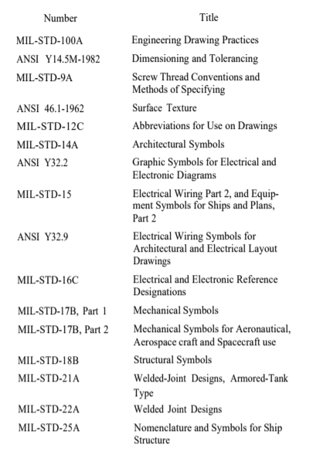

Some general parts of blueprints include information blocks, finish marks, notes, specifications, legends, and symbols.

The draftsman uses information blocks to give the reader additional information about materials, specifications, and so forth that are not shown in the blueprint or that may need additional explanation.

A basic layout for many blueprints is demonstrated below:

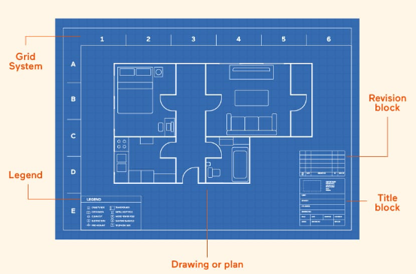

A grid system in a blueprint is a network of horizontal and vertical lines that divide the drawing area into squares or rectangles, providing a precise coordinate system for design elements. It helps create accurate drawings, measure and scale designs, and align elements with ease. The grid consists of grid lines, squares or modules, and coordinates that enable precise location and communication among designers, making it a fundamental tool in architecture, engineering, and design.

A legend in a blueprint is a key that explains the symbols, abbreviations, and conventions used in the drawing, ensuring clear communication and understanding of the design. It provides a reference guide for the various elements and notations, defining graphical symbols, abbreviations, and drawing conventions, and often includes additional notes and explanations. Located in a corner of the blueprint, the legend is an essential component that helps architects, engineers, and builders accurately interpret and execute the design.

The title block is often located in the lower-right corner of all blueprints and drawings. It contains the drawing number, name of the part or assembly that it represents, and all information required to identify the part or assembly.

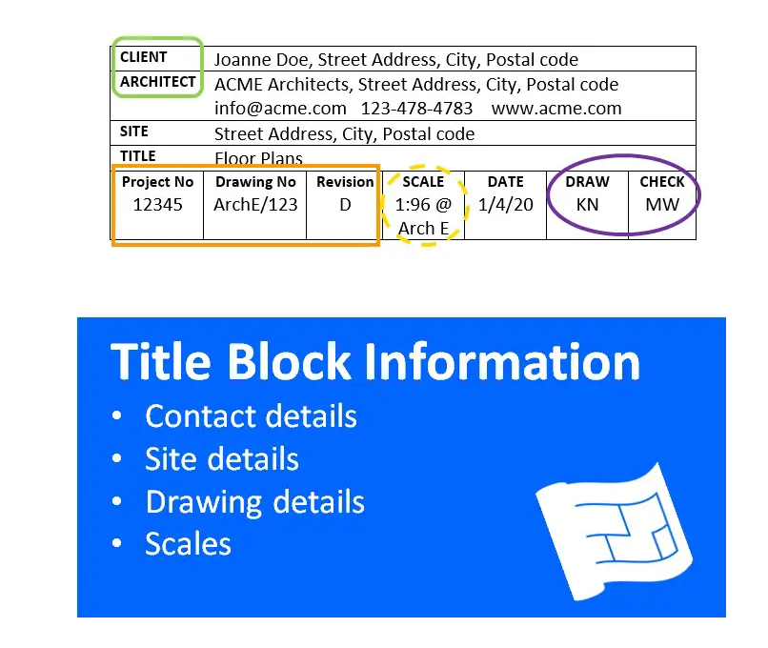

A space within the title block with a diagonal or slant line drawn across it shows that the information is not required or is given elsewhere on the drawing.

Revision blocks: a dedicated section that tracks changes and updates made to the design. It includes essential information such as revision number, date, description of changes, and approval details. This block provides a record of modifications, ensuring accuracy and accountability in architectural, engineering, and construction drawings. These are frequently found in the upper right corner of a blueprint.

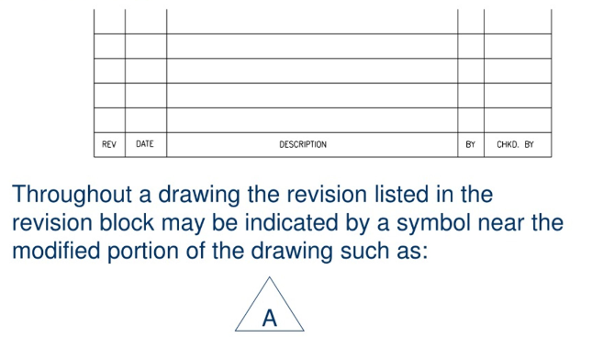

When a blueprint is revised, the letter A in the revision block is replaced by the letter B and so forth.

Reference numbers that appear in the title block refer to numbers of other blueprints. A dash and a number show that more than one detail is shown on a drawing. When two parts are shown in one detail drawing, the print will have the drawing number plus a dash and an individual number.

In addition to appearing in the title block, the dash and number may appear on the face of the drawings near the parts they identify. A dash and number identify changed or improved parts and right-hand and left-hand parts.

On some prints you may see a notation above the title block such as “159674 LH shown; 159674-1 RH opposite.” Both parts carry the same number. LH means left hand, and RH means right hand. Some companies use odd numbers for right-hand parts and even numbers for left-hand parts.

Zone numbers serve the same purpose as the numbers and letters printed on borders of maps to help you locate a particular point or part.

The scale block in the title block of the blueprint shows the size of the drawing compared with the actual size of the part. The scale is chosen to fit the object being drawn and space available on a sheet of drawing paper.

Never measure a drawing; use dimensions. The print may have been reduced in size from the original drawing. Read the dimensions on the drawing; they always remain the same.

The bill of material block contains a list of the parts and/or material needed for the project. The block identifies parts and materials by stock number or other appropriate number, and lists the quantities requited.

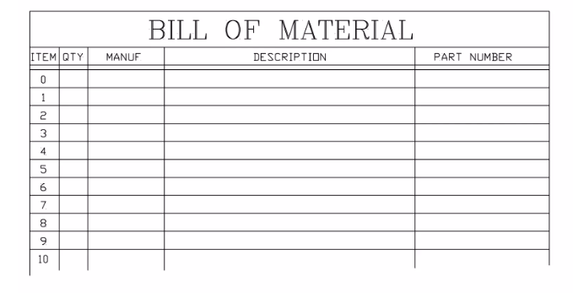

The application block on a blueprint tells you where the part or assembly shown fits into a bigger machine or system. It points out what larger unit the part belongs to.

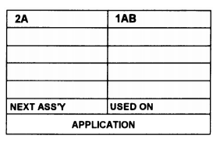

Finish marks- checkmarks- are used on machine drawings show surfaces to be finished by machining. Machining provides a better surface appearance and a better fit with closely mated parts.

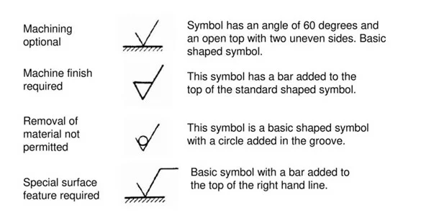

Notes are placed on drawings to give additional information to clarify the object on the blueprint.



A specification is a statement or document containing a description such as the terms of a contract or details of an object or objects not shown on a blueprint or drawing.

The legend explains or defines a symbol or special mark placed on the blueprint.

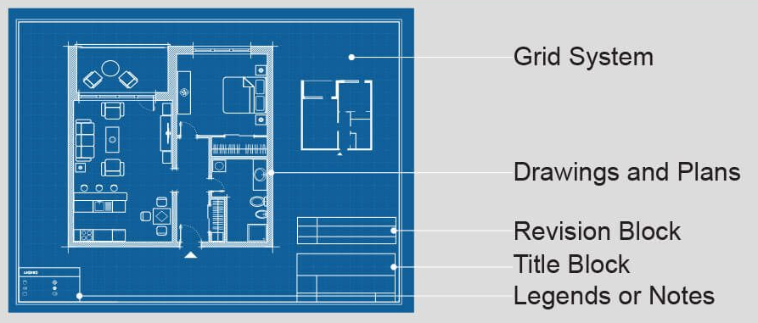

Lines in blueprints, also known as engineering drawings, are a visual language that convey important information about the design, dimensions, and features of a structure or component. Different types of lines are used to distinguish between elements, enhance clarity, and convey specific information.

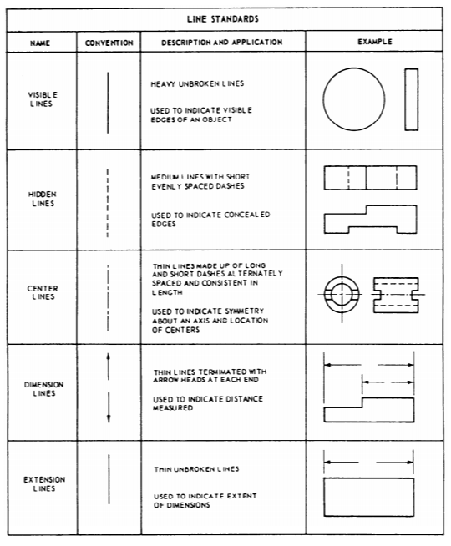

Preliminary plans are submitted with bids or other plans before a contract is awarded.

Contract plans illustrate mandatory design features of a ship.

Contract guidance plans illustrate design features of a ship subject to development.

Standard plans illustrate arrangement or details of equipment, systems, or parts where specific requirements are mandatory.

Type plans illustrate the general arrangement of equipment, systems, or parts that do not require strict compliance to details as long as the work gets the required results.

Working plans are those the contractor uses to construct a ship.

Corrected plans are those that have been corrected to illustrate a final ship and system arrangement, fabrication, and installation.

Onboard plans are those considered necessary as reference materials in the operation of a ship.

An SPI (ship’s plan index) lists all plans that apply to a ship except those for certain miscellaneous items covered by standard or type plans.

Blueprints can be fragile documents. Some simple tips to care for them include:

* Keep them out of sunlight to prevent fading
* Try to keep them from grease or other types of chemical smudging
* Don’t make pencil or other notations without authority from proper personnel
* Keep them stored away just as they were received to prevent tearing or folding

Below is a list of common line types in blueprints. Some were already discussed, but this is a more extensive list.

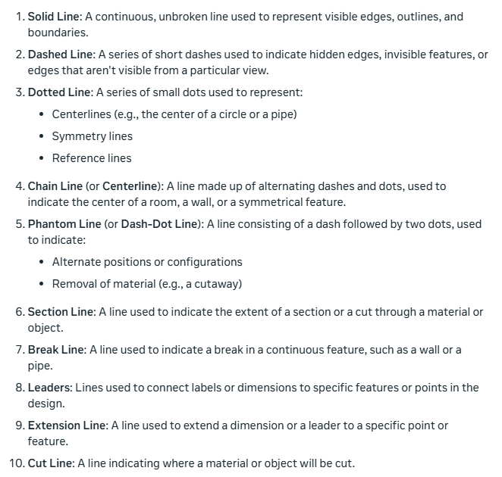

By integrating CAD and CNC, designers and manufacturers can produce high-quality parts with increased efficiency and accuracy, reducing the time and cost associated with traditional manufacturing methods.

The process of preparing engineering drawings on a computer is known as computer-aided drafting (CAD).

A CNC (Computer Numerical Control) machine is a computer-controlled manufacturing device that uses programming language to execute precise movements and actions, such as cutting, drilling, or shaping, on various materials like metal, wood, or plastic.

Computer-generated instructions can be stored in a central computer’s memory, or on a disk, for direct transfer to one or more CNC machine tools that will make the parts. This is known as direct numerical control (DNC).

CAM (Computer-Aided Manufacturing) is software used to control machine tools and manufacturing processes by taking a CAD instruction and converting it to machine-readable instructions (G-code).

CAD/CAM stands for Computer-Aided Design (CAD) and Computer-Aided Manufacturing (CAM). It's a combination of two technologies that work together to streamline the design-to-manufacturing process.

In blueprint reading, a view of an object is known technically as a projection. Projection is done, in theory, by extending lines of sight called projectors from the eye of the observer through lines and points on the object to the plane of projection.

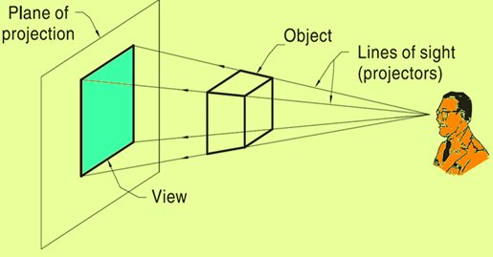

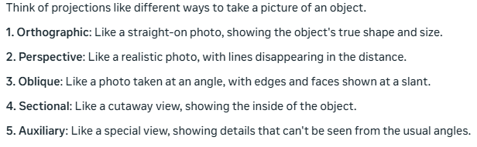

A perspective drawing is the most used method of presentation used in technical illustrations in the commercial and architectural fields. The drawn objects appear proportionately smaller with distance, as they do when you look at the real object.

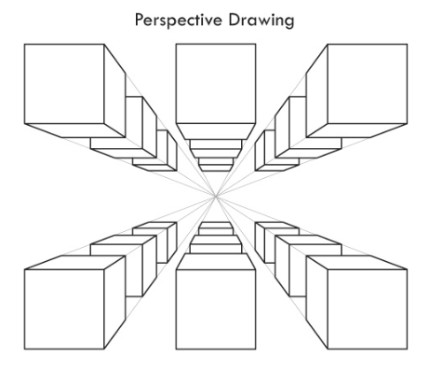

Auxiliary views are often necessary to show the true shape and length of inclined surfaces, or other features that are not parallel to the principal planes of projection.

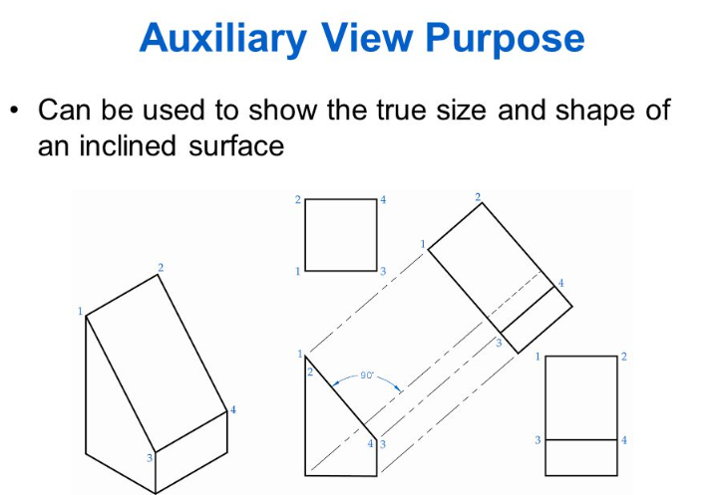

Section views give a clearer view of the interior or hidden features of an object that you normally cannot see clearly in other views. A section view is made by visually cutting away a part of an object to show the shape and construction at the cutting plane. When sectional views are drawn, the part that is cut by the cutting plane is marked with diagonal (or crosshatched), parallel section lines.

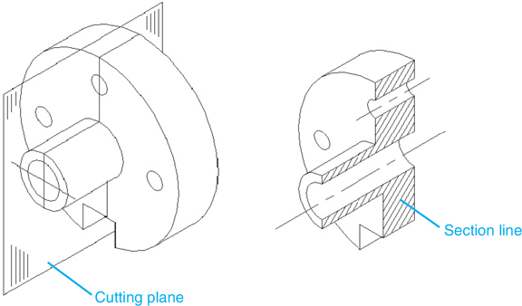

In blueprints, an offset section is a type of view that shows a portion of the building or object at an angle, usually to clarify the relationship between different parts of the structure.

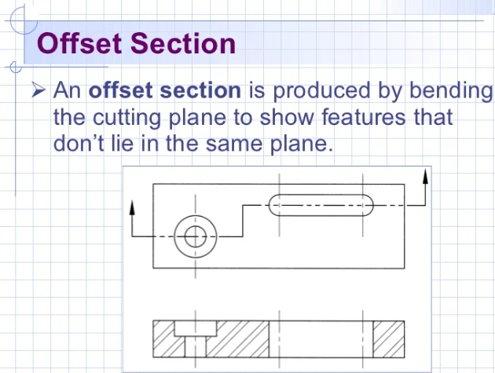

Half section: This type of section is used when an object is symmetrical in both outside and inside details. One-half of the object is sectioned; the other half is shown as a standard view.

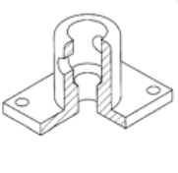

Revolved section: This type of section is used to eliminate the need to draw extra views of rolled shapes, ribs, and similar forms. It is really a drawing within a drawing, and it clearly describes the object’s shape at a certain cross section.

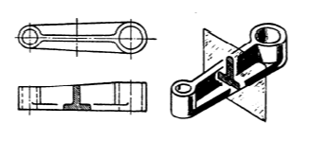

Removed section: This type of section is used to illustrate particular parts of an object. It is drawn like the revolved section, except it is placed at one side to bring out important details.

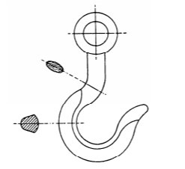

Broken-out section: The inner structure of a small area may be shown by peeling back or removing the outside surface.

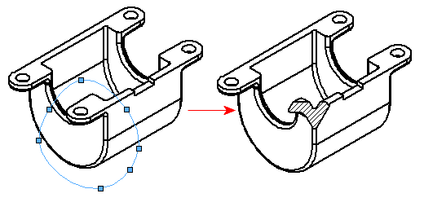

An aligned section in blueprints shows angled parts as if they were cut and rotated to face the viewer directly. This makes it easier to see the real shape and size of complex features that aren't straight up-and-down or side-to-side in the main drawing.

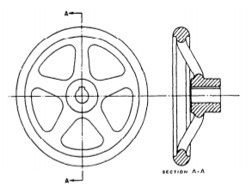

An exploded view in blueprint reading is a diagram that shows all the parts of an object separated but in the correct order. It's like the object has been pulled apart in mid-air, with the pieces floating in their relative positions. This type of view helps show how different parts fit together and makes it easier to understand the assembly process.

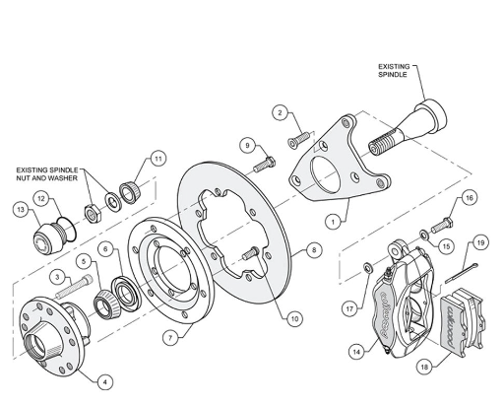

A detail drawing is a print that shows a single component or part. It includes a complete and exact description of the part’s shape and dimensions, and how it is made. A complete detail drawing will show in a direct and simple manner the shape, exact size, type of material, finish for each part, tolerance, necessary shop operations, number of parts required, and so forth.

In learning to read machine drawings, you must first become familiar with the common terms, symbols, and conventions.

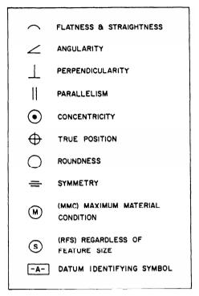

Tolerances: A tolerance in engineering is the acceptable range of variation for a dimension or measurement. It defines how much a part can deviate from its ideal size or shape while still being considered functional and acceptable.

Fillets are smooth, curved inside corners in metal parts. They make cast metal stronger by helping it cool evenly. This reduces the chance of breaks. Rounds (or radii) are smooth, curved outside corners. They prevent chipping and remove sharp edges. Both fillets and rounds replace sharp angles with gentle curves, but fillets are on the inside and rounds are on the outside.

Slots and slides are used to mate two specially shaped pieces of material and securely hold them together, yet allow them to move or slide.

Keys, keyways, and keysets are used to join rotating parts in machines. A key is a small metal piece that fits into matching slots (keyways) in a shaft and the part it drives. This prevents the parts from spinning separately. The whole assembly is called a keyset. It's a simple way to transfer rotational motion between parts.

Thread classes used to be called "class of fit." The National Bureau of Standards changed the name to "class of thread" in their official standards. However, people will likely keep using the old term "class of fit" for a long time.

Helix: The curve formed on any cylinder by a straight line in a plane that is wrapped around the cylinder with a forward progression.

External Thread: A thread on the outside of a member. An example is the thread of a bolt.

Internal Thread: A thread on the inside of a member. An example is the thread inside a nut.

Major Diameter: The largest diameter of an external or internal thread.

Axis: The center line running lengthwise through a screw.

Crest: The surface of the thread corresponding to the major diameter of an external thread and the minor diameter of an internal thread.

Root: The surface of the thread corresponding to the minor diameter of an external thread and the diameter of an internal thread.

Depth: The distance from the root of a thread to the crest, measured perpendicularly to the axis.

Pitch: The distance from a point on a screw thread to a corresponding point on the next thread, measured parallel to the axis.

Lead:The distance a screw thread advances on one turn, measured parallel to the axis. On a single-thread screw the lead and the pitch are identical; on a double-thread screw the lead is twice the pitch; on a triple-thread screw the lead is three times the pitch.

When gears are drawn on machine drawings, draftsmen usually just draw enough teeth to represent the gear. Below is some terminology related to gears.

Pitch Diameter (PD): The diameter of the pitch circle (or line), which equals the number of teeth on the gear divided by the diametral pitch

Diametral Pitch (DP): The number of teeth to each inch of the pitch diameter or the number of teeth on the gear divided by the pitch diameter. Diametral pitch is usually referred to as simply pitch.

Number Of Teeth (N): The diametral pitch multiplied by the diameter of the pitch circle (DP x PD).

Addendum Circle (AC): The circle over the tops of the teeth.

Outside Diameter (OD): The diameter of the addendum circle.

Circular Pitch (CP): The length of the arc of the pitch circle between the centers or corresponding points of adjacent teeth.

Addendum (A): The height of the tooth above the pitch circle or the radial distance between the pitch circle and the top of the tooth.

Dedendum (D): The length of the portion of the tooth from the pitch circle to the base of the tooth.

Chordal Pitch: The distance from center to center of teeth measured along a straight line or chord of the pitch circle.

Root Diameter (RD): The diameter of the circle at the root of the teeth.

Clearance (C): The distance between the bottom of a tooth and the top of a mating tooth.

Whole Depth (WD): The distance from the top of the tooth to the bottom, including the clearance.

Face: The working surface of the tooth over the pitch line.

Thickness: The width of the tooth, taken as a chord of the pitch circle.

Pitch Circle: The circle having the pitch diameter.

Working Depth: The greatest depth to which a tooth of one gear extends into the tooth space of another gear.

Rack Teeth: A rack may be compared to a spur gear that has been straightened out. The linear pitch of the rack teeth must equal the circular pitch of the mating gear.

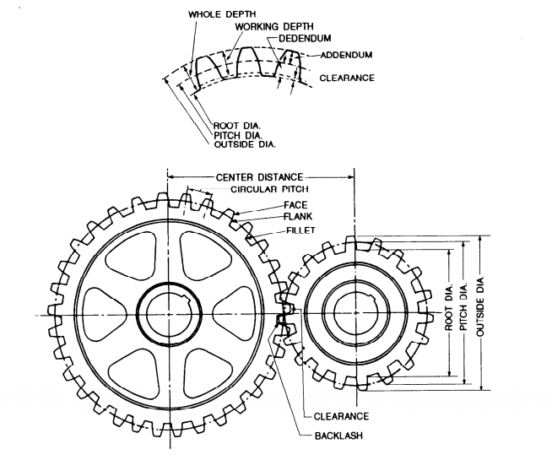

There are three classifications of helical springs: compression, extension, and torsion. Drawings seldom show a true presentation of the helical shape; instead, they usually show springs with straight lines.

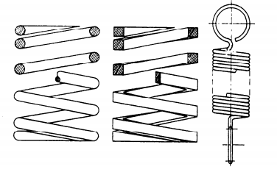

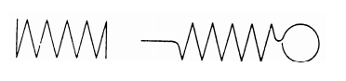

A modified symbol (check mark) with a number or numbers above it is used to show surfaces requiring a finish and to specify the degree of finish.

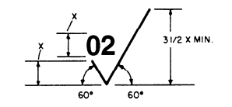

The number in the angle of the check mark, in this case 02, tells the machinist what degree of finish the surface should have.

Surface roughness symbol is drawn touching the line representing the surface. If space is limited, the symbol may be placed on an extension line on that surface or on the tail of a leader with an arrow touching that surface.

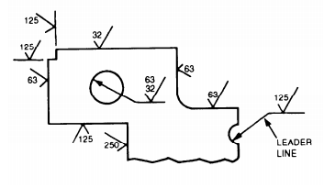

When a part is to be finished to the same roughness all over, a note on the drawing will include the direction “finish all over” along the finish mark and the proper number.

When a part is to be finished all over but a few surfaces vary in roughness, the surface roughness symbol number or numbers are applied to the lines representing these surfaces and a note on the drawing will include the surface roughness symbol for the rest of the surfaces.

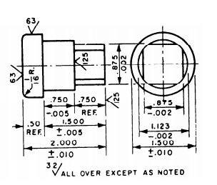

American industry has adopted a new standard, Geometrical Dimensioning and Tolerancing, ANSI Y14.5M-1982. This standard is used in all blueprint production whether the print is drawn by a human hand or by computer-aided drawing (CAD) equipment. It standardizes the production of prints.

Piping drawings show the size and location of pipes, fittings, and valves. A set of symbols has been developed to identify these features on drawings. Two methods of projection used in pipe drawings are orthographic and isometric (pictorial).

Single- and double-line orthographic pipe drawings are recommended for showing single pipes either straight or bent in one plane only.

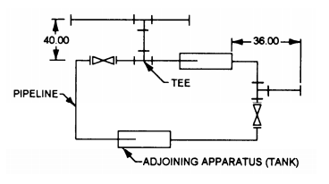

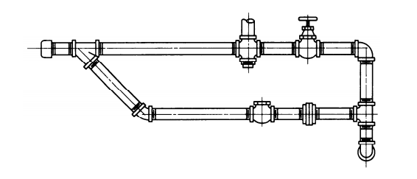

The crossing of pipes without connections is normally shown without interrupting the line representing the hidden line. When there is a need to show that one pipe must pass behind another, the line representing the pipe farthest from the viewer will be shown with a break, or interruption, where the other pipe passes in front of it.

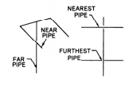

If standard symbols for fittings like tees, elbows, crossings, and so forth are not shown on a drawing, they are represented by a continuous line. The circular symbol for a tee or elbow may be used when it is necessary to show the piping coming toward or moving away from the viewer.

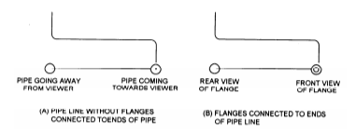

The below screenshots show some additional piping, valve, and connection symbols.

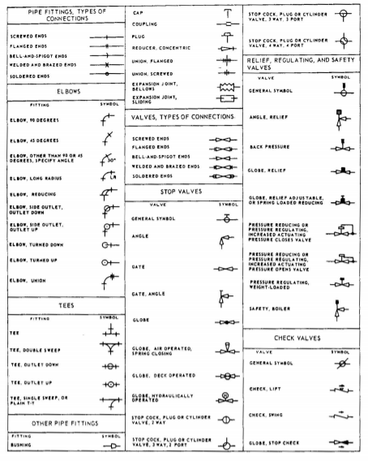

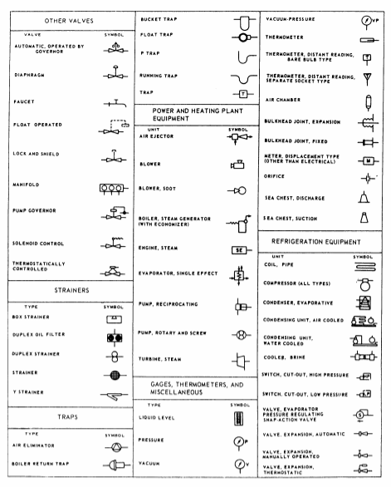

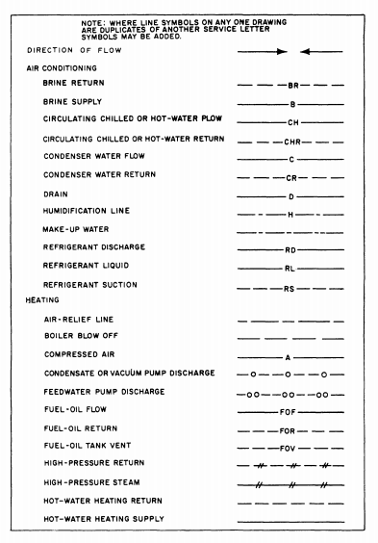

Different rules, or standards, apply for blueprints depending on who/why they are being drawn up. But a good rule is that colors are painted on valve wheels and pipe lines carrying hazardous fluids.

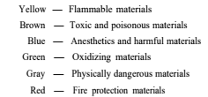

Some additional markings that may show on blueprints help to identify hazards. Again, blueprint standards may differ according to the organization or discipline they are being used in.

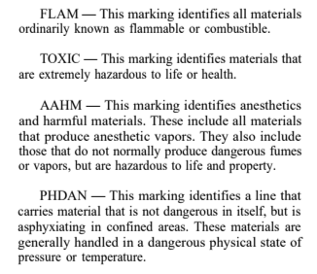

You may also encounter hydraulic symbols. These may include:

Supply Lines: These lines carry fluid from the reservoir to the pumps. They may be called suction lines.

Pressure Lines: These lines carry only pressure. They lead from the pumps to a pressure manifold, and from the pressure manifold to the various selector valves. Or, they may lead directly from the pump to the selector valve.

Operating Lines: These lines alternately carry pressure to, and return fluid from, an actuating unit. They also may be called working lines. Each line is identified according to its specific function.

Return Lines: These lines return fluid from any portion of the system to a reservoir.

Vent Lines: These lines carry excess fluid overboard or into another receptacle.

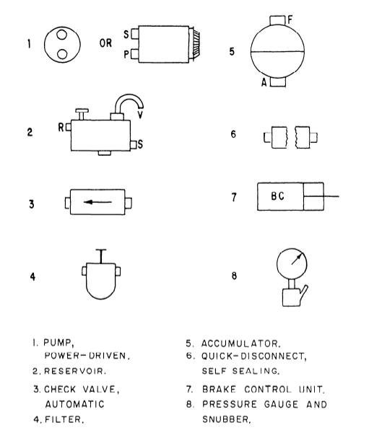

Lines and arrows are typically used in hydraulic blueprints to indicate direction of movement:

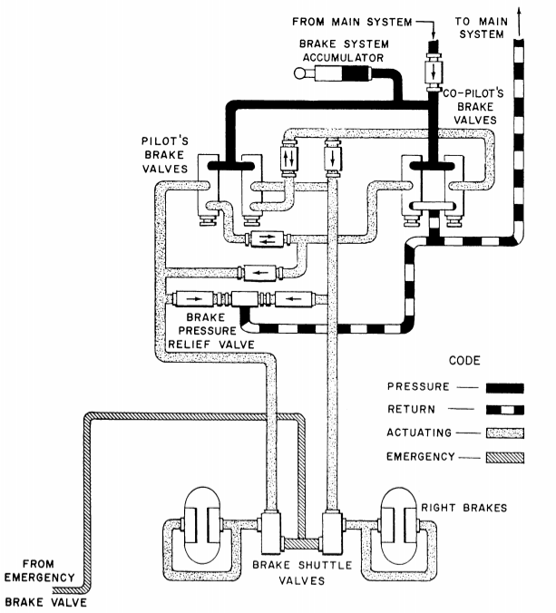

Plumbing prints may use some of the pipe symbols shown previously. However, there are others that may be used.

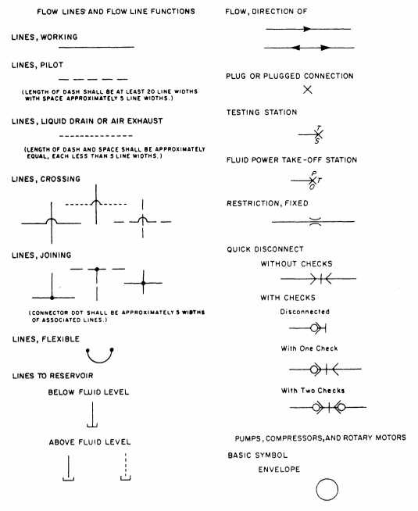

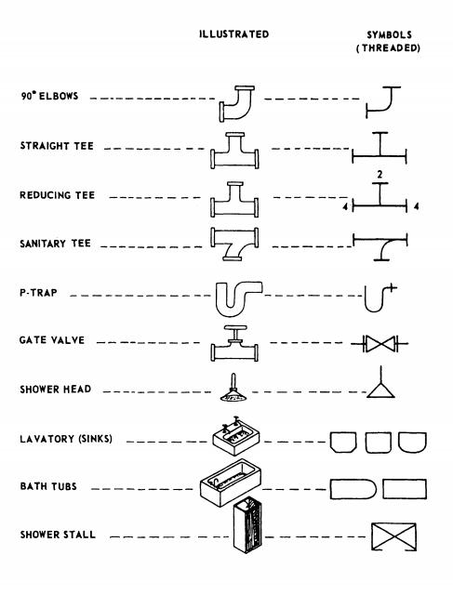

For fittings, remember that on crosses and elbows, you always read the largest opening first and then follow the alphabetical order. On tees, 45-degree Y-bends or laterals, and double-branch elbows, you always read the size of the largest opening of the run first, the opposite opening of the run second, and the outlet last.

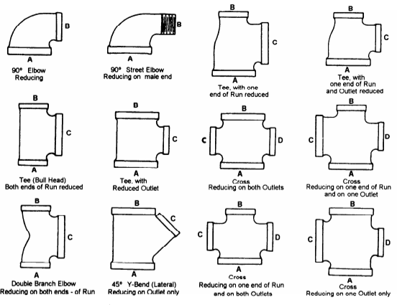

A pictorial wiring diagram is made up of pictorial sketches of the various parts of an item of equipment and the electrical connections between the parts.

An isometric wiring diagram shows the outline of a ship or aircraft or other structure, and the location of equipment such as panels, connection boxes, and cable runs.

A single-line diagram uses lines and graphic symbols to simplify complex circuits or systems.

A schematic diagram uses graphic symbols to show how a circuit functions electrically.

An elementary wiring diagram shows how each individual conductor is connected within the various connection boxes of an electrical circuit or system. It is sometimes used interchangeably with schematic diagram, especially a simplified schematic diagram.

In a block diagram, the major components of equipment or a system are represented by squares, rectangles, or other geometric figures, and the normal order of progression of a signal or current flow is represented by lines. An example of a block diagram is shown below.

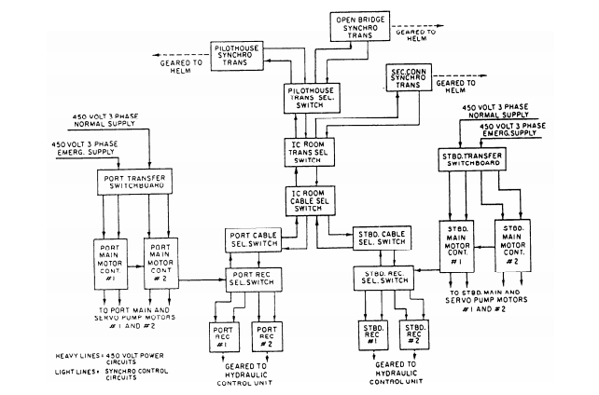

Electronics prints are similar to electrical prints, but they are usually more difficult to read because they represent more complex circuitry and systems.

Block diagrams that break down the simplified diagram into enough detail to show a fairly detailed picture of functional operation, but do not include wave forms, test points, and so on, are usually called functional block diagrams.

A detailed schematic diagram shows detailed information about circuits and parts and must be used in conjunction with a detailed block diagram to effectively troubleshoot a system.

A reference designation is a combination of letters and numbers used to identify the various parts and components on electronic drawings, diagrams, parts lists, and so on. The prints you work with will have one of two systems of reference designations. The old one is called a block numbering system and is no longer in use. The current one is called a unit numbering system. In that reference designation system, electronic systems are broken into sets, units, assemblies, subassemblies, and parts. A system is defined as two or more sets and other assemblies, subassemblies, and parts necessary to perform an operational function or functions.

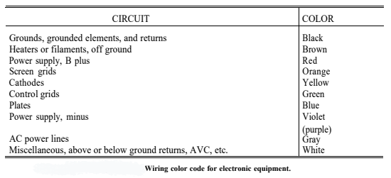

A set is defined as one or more units and the necessary assemblies, subassemblies, and parts connected or associated together to perform an operational function.

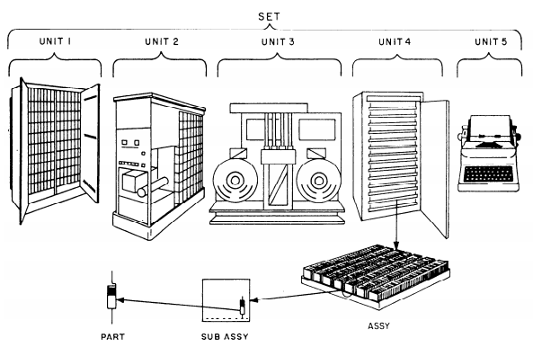

Reference designations are typically assigned beginning with the unit and continuing down to the lowest level (parts).

Units are usually assigned a number beginning with 1 and continuing with consecutive numbers for all units of the set. This number is the complete reference designation for the unit. If there is only one unit, the unit number is omitted.

Assemblies and subassemblies are typically assigned reference designations consisting of the unit number that identifies the unit of which the assembly or subassembly is a part, the letter A indicating an assembly or subassembly, and a number identifying the specific assembly or subassembly.

Parts are often assigned reference designations that consist of the unit and assembly or subassembly designation, plus a letter or letters identifying the class to which the part belongs (as in the block numbering system), and a number identifying the specific part.

For each additional subassembly, an additional letter A and number are added to the part reference designation.

On electronic diagrams, the usual procedure is to use partial (abbreviated) reference designations. In this procedure, only the letter and number identifying the part is shown on the part itself, while the reference designation prefix appears at some other place on the diagram. For the complete reference designation, the designation prefix precedes the partial designation.

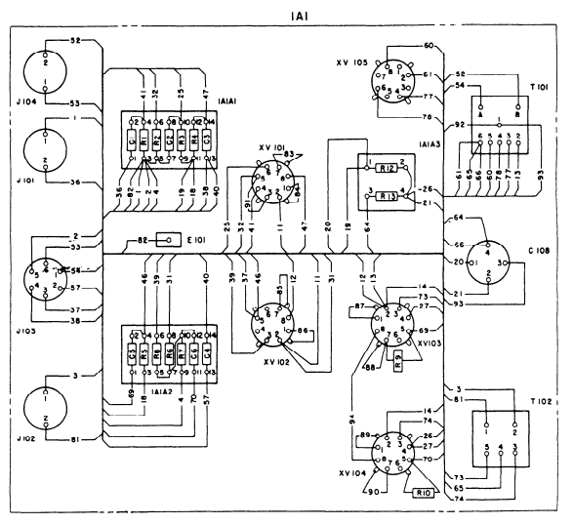

Interconnection diagrams show the cabling between electronic units and how the units are interconnected.

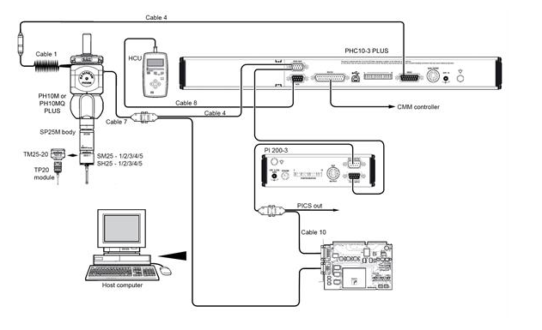

Individual conductors connecting to terminal boards are tagged with a vinyl sleeving called spaghetti that shows the terminal board and terminal to which the outer end of the conductor is connected.

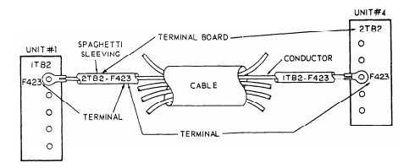

Electromechanical systems, such as synchros and gyros, require more than electrical or electronic drawings to understand. That's why we use simplified electromechanical drawings, which show only the essential electrical and mechanical components needed for operation.

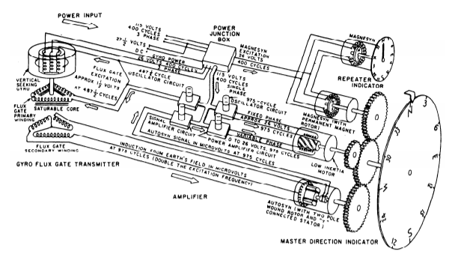

Digital computers are used to make logic decisions about matters that can be decided logically.

People use many logical truths in everyday life without realizing it. Most of the simple logical patterns are distinguished by words such as *and*, *or*, *not*, *if*, *else*, and *then*. Once the verbal reasoning process has been completed and results put into statements, the basic laws of logic can be used to evaluate the process. Although simple logic operations can be performed by manipulating verbal statements, the structure of more complex relationships can more usefully be represented by symbols. Thus, the operations are expressed in what is known as symbolic logic, which was developed by George Boole.

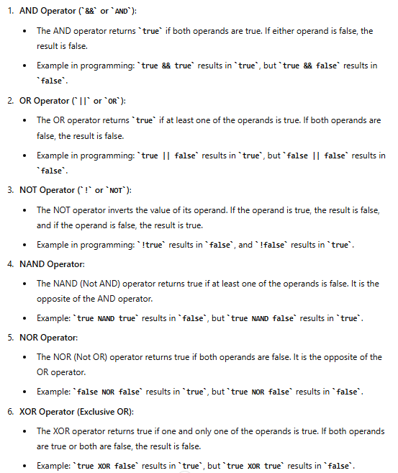

Truth tables are often used to represent the outcomes of logical operators. Here is a truth table for the AND operator:

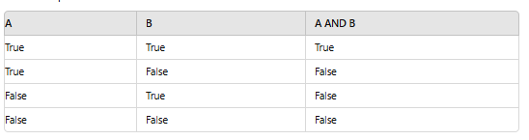

Basic logic diagrams are used to show the operation of a particular unit or component. Basic logic symbols are shown in their proper relationship so as to show operation only in the most simplified form possible.

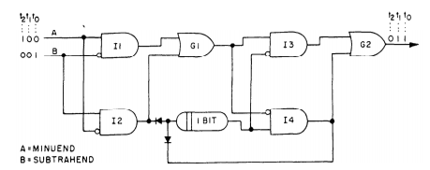

Detailed logic diagrams show all logic functions of the equipment concerned. In addition, they also include such information as socket locations, pin numbers, and test points to help in troubleshooting.

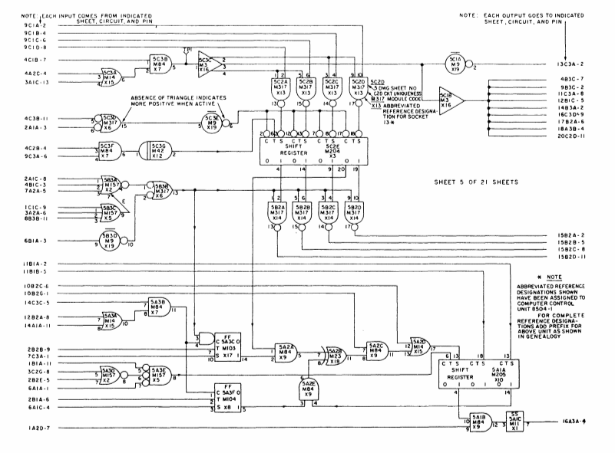

A building project may be broadly divided into two major phases, the design phase and the construction phase. First, the architect conceives the building, ship, or aircraft in his or her mind, then sets down the concept on paper in the form of presentation drawings, which are usually drawn in perspective by using pictorial drawing techniques. Next, the architect and the engineer work together to decide upon materials and construction methods. The engineer determines the loads the supporting structural members will carry and the strength each member must have to bear the loads. He or she also designs the mechanical systems of the structure, such as heating, lighting, and plumbing systems.

When noted, lengths are usually given in feet and inches.

A beam is identified by its nominal depth, in inches and weight per foot of length.

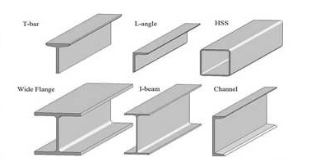

Structural Channels: These are grooves or recesses in walls, floors, or ceilings designed to carry utilities like water, electricity, or HVAC systems. Channels in this sense help conceal and protect pipes, wires, or ducts while allowing easy access for maintenance. Channels are identified by their nominal depth and weight per foot.

Steel Angles: In some construction, "angle iron" or "L-angles" are L-shaped structural pieces used to create frames and reinforce joints. These are typically used in construction where durability and load-bearing capacity are critical. Angles are identified by the dimensions in inches of their legs.

In steel construction, a structural steel tee is a type of beam or girder with a T-shaped cross-section, often created by cutting an I-beam along its length. These T-sections are versatile and widely used as support beams in floors, roofs, and other structural components, particularly in scenarios where only one flange is needed to resist bending forces.

A bearing pile is a type of deep foundation used in construction to transfer the load of a structure to a deeper, more stable layer of soil or rock. Bearing piles are driven or drilled into the ground until they reach a strong, load-bearing stratum, such as bedrock or a dense layer of soil, which can support the weight of the structure above.

A Zee section has a Z-shaped cross-section, characterized by two horizontal flanges connected by a vertical web. This shape gives it distinct structural properties that are different from other standard shapes like I-beams, C-channels, or L-angles.

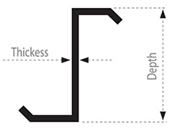

In architecture and structural engineering, plates refer to flat, typically rectangular or square pieces of material that are used in various applications due to their ability to distribute loads over a broad area. Plates can be made from a range of materials, including steel, concrete, wood, or aluminum, and they serve different functions depending on their use in a structure.

Flat bars are commonly used in construction, manufacturing, and fabrication for purposes such as bracing, support, frameworks, and other structural applications. They are versatile and can be easily cut, welded, drilled, or machined to fit a wide range of uses.

Tie rods are slender structural elements designed to resist stretching or pulling forces and stabilize structures, often used in bridges and frameworks.

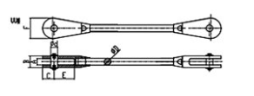

Pipe columns, made from pipes, serve as vertical supports to carry loads and transfer weight to the foundation, commonly found in buildings and industrial settings. Both components are essential for maintaining structural integrity and managing different types of stresses.

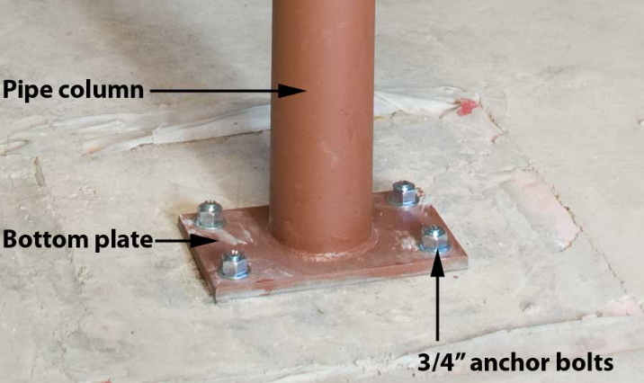

A dead load is the constant, permanent weight of a structure and its fixed components, including materials and installations.

A live load is the variable weight from occupants, furniture, and movable items that changes over time.

The main parts of a structure are load-bearing members that support and transfer loads while maintaining equilibrium. Connections between members are called joints. At any given moment, the total load on the structural members equals the sum of the dead load and the live load.

Soil-bearing capacity is the earth's ability to support a load, measured in pounds per square foot. It varies by soil type and increases with wider foundations or footings.

Columns, or pillars, are strong vertical structural members. In buildings, outside-wall columns extend from footings to the roof, while bottom-floor inside columns rise to support the first floor. Upper-floor columns are typically aligned with those below.

A pier in building construction is a short column that supports horizontal structural members. It can rest on a footing or be driven into the ground. In bridge construction, a pier is a vertical support for the bridge superstructure.



Light frame construction is a building method that uses a skeleton of wood or steel frames to support a building's weight and loads

In light-frame construction, the main vertical structural members are studs, supported by horizontal sills or sole plates and topped with top plates or stud caps. Corner posts, which are enlarged studs at building corners, were originally solid timber in early construction but are now typically built up from multiple studs.

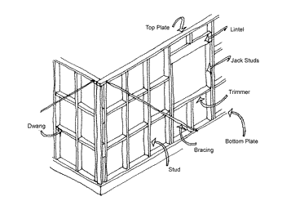

In technical terminology, a horizontal load-bearing structural member that spans a space and is supported at both ends is called a beam. A member that is fixed at one end is called a cantilever.

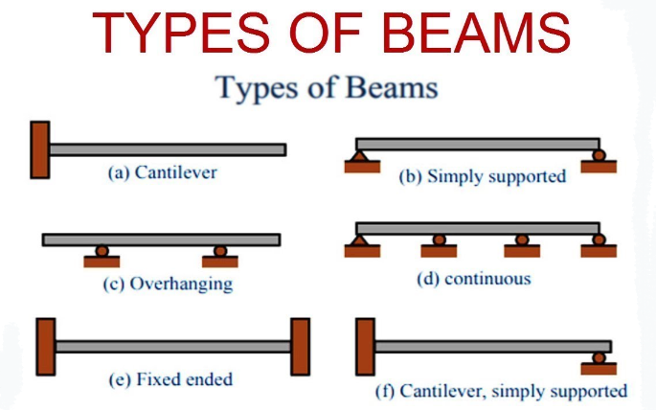

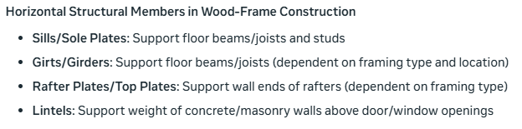

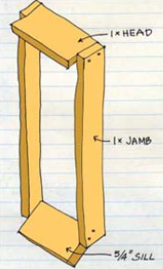 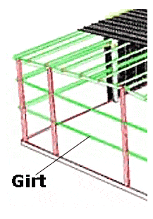 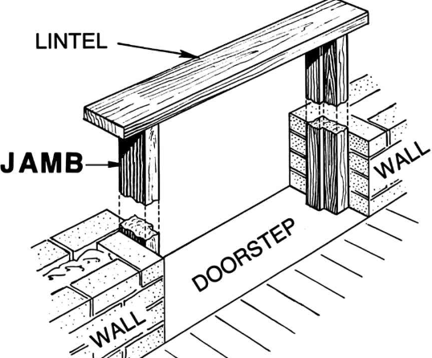 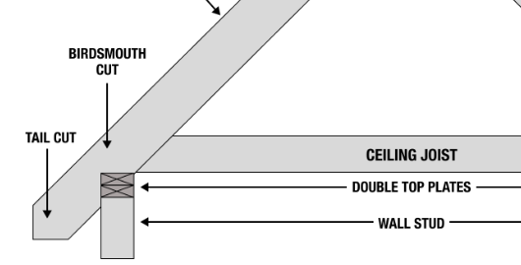

A truss is a framework consisting of two horizontal (or nearly horizontal) members joined together by a number of vertical and/or inclined members to form a series of triangles. The loads are applied at the joints. The horizontal members are called the upper or top chords and lower or bottom chords. The vertical and/or inclined members that connect the top and bottom chords are called web members.

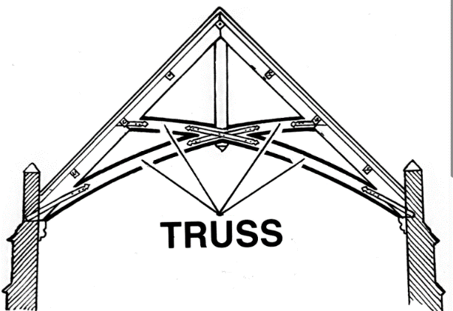

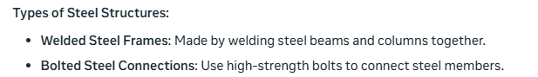

Welding symbols on blueprints are crucial for clear communication of welding requirements, ensuring accuracy and reducing errors. They provide a standardized way to specify key details, enabling fabricators to produce high-quality welds that meet design intent and safety standards. In essence, welding symbols bridge the gap between design and fabrication, facilitating effective translation of design requirements into physical reality.

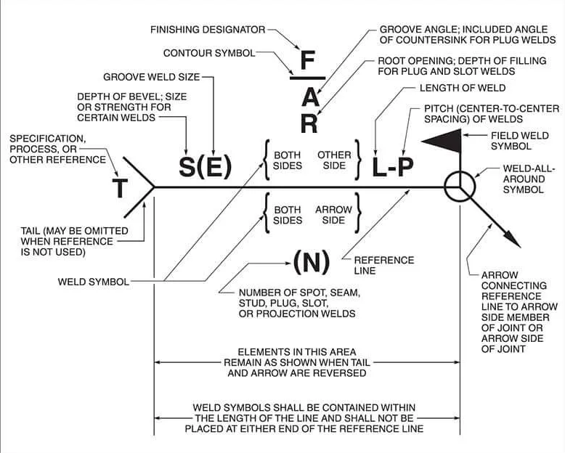

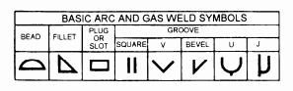

Riveted structures, commonly used in bridges, aircraft, and ships, offer strong joints but require careful consideration of key factors. Their strength can be compromised by fatigue, corrosion, and inadequate maintenance, making regular inspection crucial. Proper upkeep, including re-tightening or replacing rivets, is vital to ensure the safety and longevity of these structures. By understanding and addressing these factors, the integrity and reliability of riveted structures can be maintained.

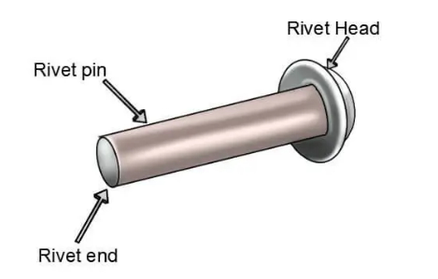 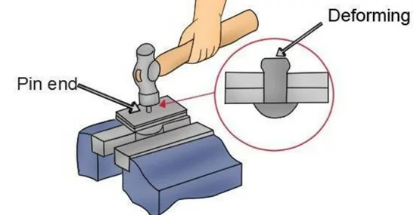

Layout drawings are also called general plans and profile drawings. They provide the necessary information on the location, alignment, and elevation of the structure and its principal parts in relation to the ground at the site.

General plans provide an overview of a structure's main components, including size, material, layout, connections, and attachments. The number of drawings varies based on the structure's size, complexity, and operational needs.

Fabrication drawings, or shop drawings, contain necessary information on the size, shape, material, and provisions for connections and attachments for each member. This information is in enough detail to permit ordering the material for the member concerned and its fabrication in the shop or yard.

Fabrication drawings, or shop drawings, contain necessary information on the size, shape, material, and provisions for connections and attachments for each member. This information is in enough detail to permit ordering the material for the member concerned and its fabrication in the shop or yard.

Falsework drawings detail temporary structures and supports needed to build or repair a permanent structure, outlining placement and removal of components like scaffolding and shoring.

Construction drawings use visual representations to convey information, typically through orthographic views. They consist of general drawings, which show plans and elevations at a small scale, and detail drawings, which display sections and details at a larger scale.

A plan view is a view of an object or area as it would appear if projected onto a horizontal plane passed through or held above the object area.

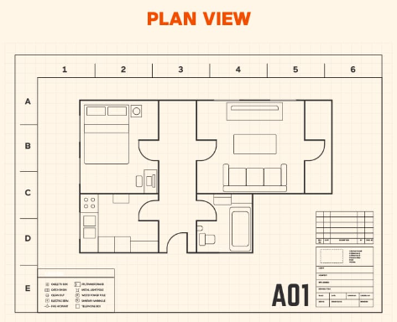

A plot plan shows the contours, boundaries, roads, utilities, trees, structures, and other significant physical features about structures on their sites. The locations of the proposed structures are indicated by appropriate outlines or floor plans.

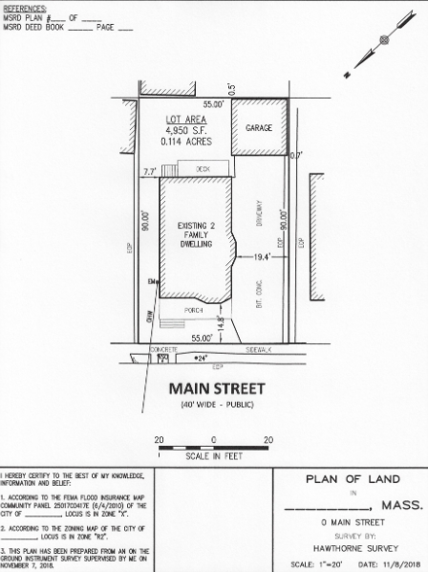

A foundation plan is a detailed diagram outlining a building's foundation design. It guides construction and ensures compliance with codes, providing a safe and stable base for the building.

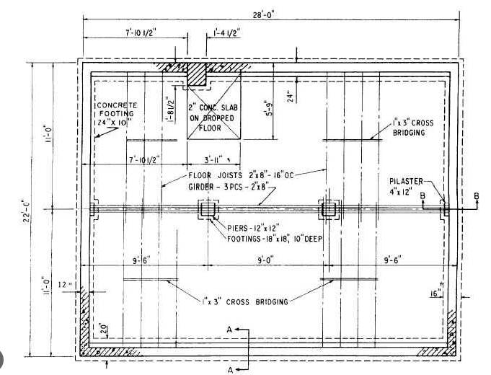

A floor plan is a scaled diagram of a building's interior, showing the arrangement of rooms, doors, windows, hallways, and other features on a single level. It's a 2D representation of a floor's layout, used in architecture, construction, and real estate to visualize and communicate spatial relationships and design intent.

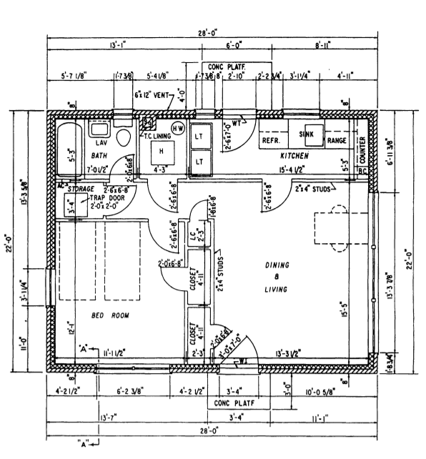

Framing plans show the dimension numbers and arrangement of structural members in wood-frame construction.

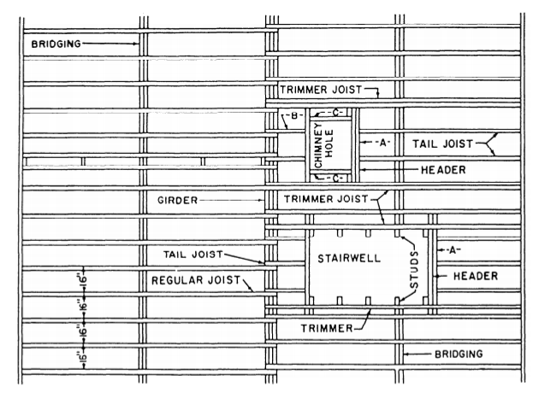

A wall framing plan is a detailed diagram showing a building's structural framework, including wall studs, joists, and openings. It guides the framing process and ensures compliance with building codes.

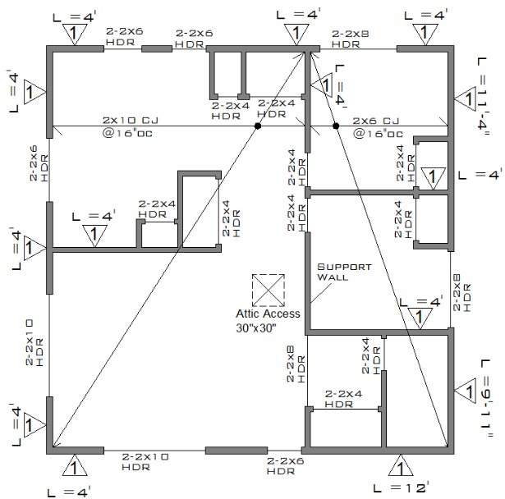

A utility plan is a floor plan that shows the layout of heating, electrical, plumbing, or other utility systems.

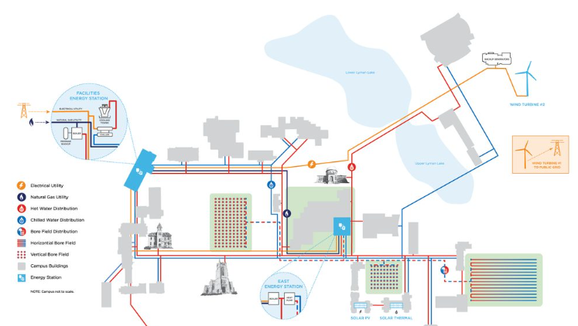

Elevations show the front, rear, and sides of a structure projected on vertical planes parallel to the planes of the sides.

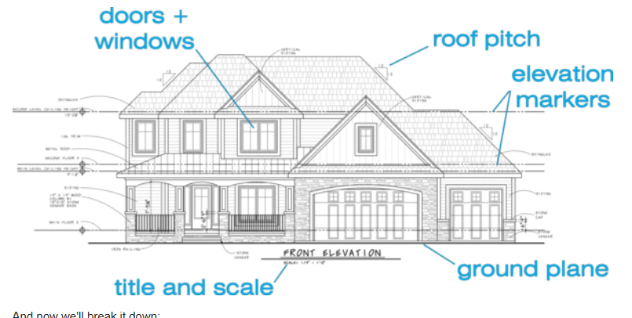

A section view is a detailed drawing that shows a vertical cut through a building or object, revealing the internal structure and relationships between different components. It's a 2D representation of a 3D space, used to illustrate construction details, spatial relationships, and internal elements.

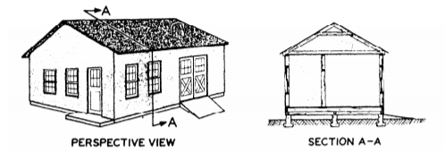

Detail drawings are on a larger scale than general drawings, and they show features not appearing at all, or appearing on too small a scale, in general drawings.

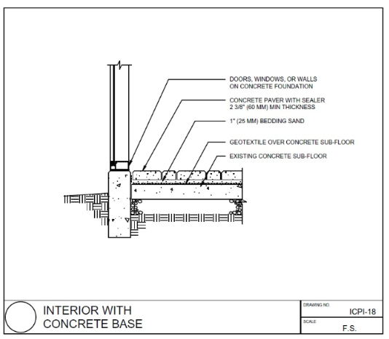

Specifications in blueprints are detailed written descriptions of the materials, finishes, and standards required for a construction project. They outline the quality, quantity, and characteristics of the materials and workmanship, providing a clear understanding of the project's requirements.

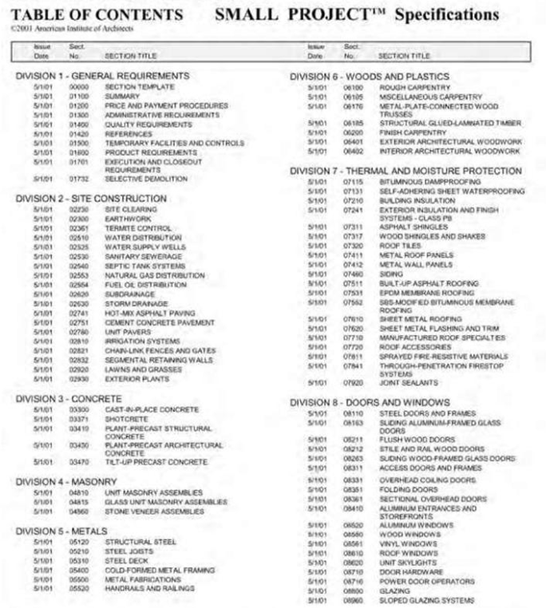

Sheet metal drawings are also known as sheet metal developments and pattern drawings.

A sheet metal development serves to open up an object that has been rolled, folded, or a combination of both, and makes that object appear to be spread out on a plane or flat surface. Sheet metal layout drawings are based on three types of development: parallel, radial, and triangulation.

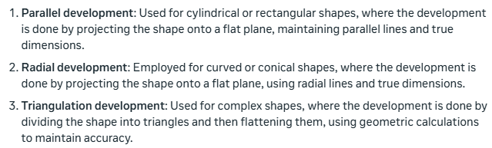

A development of an object that will be made of thin metal, such as a duct or part of an aircraft skin, must include consideration of the developed surfaces, the joining of the edges of these surfaces, and exposed edges. The drawing must allow for the additional material needed for those joints, seams, and edges.

When bending metal, it's crucial to know the bend allowance, which accounts for the metal's compression on the inside and stretching on the outside of the bend. However, there's a middle point, the neutral line, where the metal remains unaffected, neither compressing nor stretching. Understanding this helps achieve accurate bends and precise dimensions.

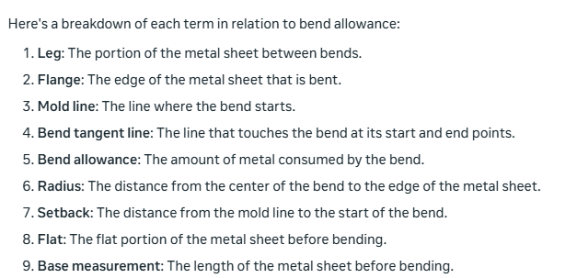

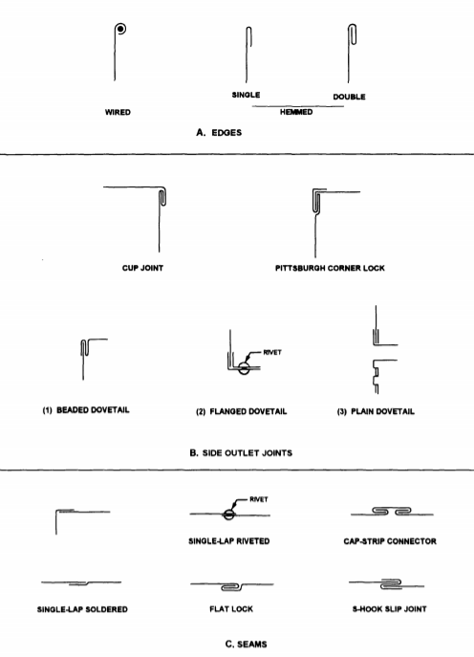

Metal 0.25 inch and over is given in inch and millimeter sizes. In calling for the material size of sheet metal developments, it is customary to give the gauge number, type of gauge, and its inch or millimeter equivalent in brackets followed by the developed width and length.

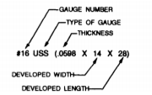

A developable surface is one that can be smoothly wrapped with a flexible material like paper. This includes flat, plane, and single-curved surfaces, which can be unfolded into a 2D shape without distortion.

A spherical shape would be an example of an approximate development. The material would be stretched to compensate for small inaccuracies.

Straight line development: Unfolding a 3D shape into a 2D pattern with straight lines, possible for single-curved or flat surfaces like cylinders, cones, or boxes.

Radial line development: Unfolding a curved 3D shape into a 2D pattern using radiating lines, used for cones, spheres, and domes.

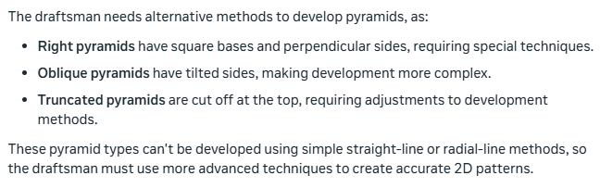

Parallel line development: A method of unfolding a 3D shape into a 2D pattern, where parallel lines are used to create the pattern. This method is used for shapes with parallel edges, like prisms, cylinders, and rectangular boxes. It's a simple and straightforward technique, often used for developing flat surfaces and straight edges.

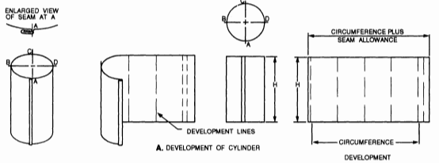

Frustum: A 3D shape formed by cutting a pyramid or cone with a plane parallel to its base, resulting in a truncated shape with a smaller top section. Think of it like a pyramid or cone with the top chopped off.

Radial line development: A method of unfolding a 3D shape into a 2D pattern, where lines radiate from a central point, like the spokes of a wheel. This method is used for shapes with curved or tapered surfaces, like cones, spheres, and domes, where parallel lines can't be used.

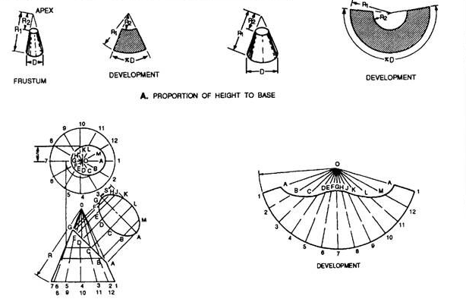

Transition pieces are usually made to connect two different forms, such as round pipes to square pipes. These transition pieces will usually fit the definition of a nondevelopable surface that must be developed by approximation. This is done by assuming the surface to be made from a series of triangular surfaces laid side-by-side to form the development.

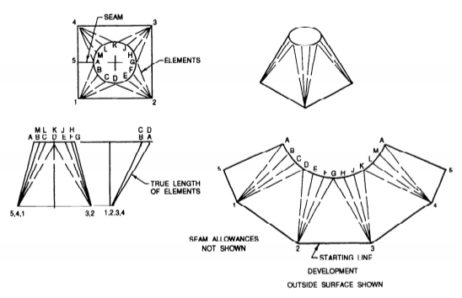

Axonometric Projection: A set of three or more views in which the object appears to be rotated at an angle, so that more than one side is seen.

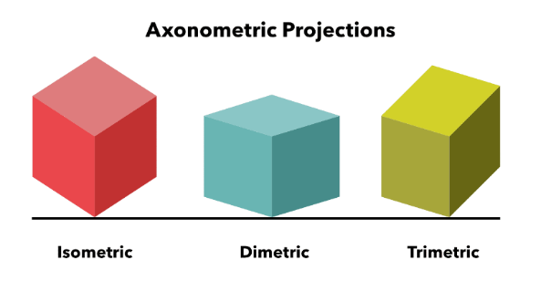

Casting: A metal object made by pouring melted metal into a mold.

Cornice: The projecting or overhanging structural section of a roof.

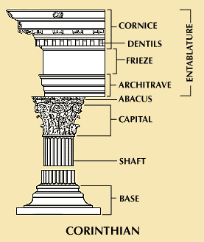

Fillet: A concave internal corner in a metal component, usually a casting.

Joist: A horizontal beam used to support a ceiling.

Manifold: A fitting that has several inlets or outlets to carry liquids or gases.

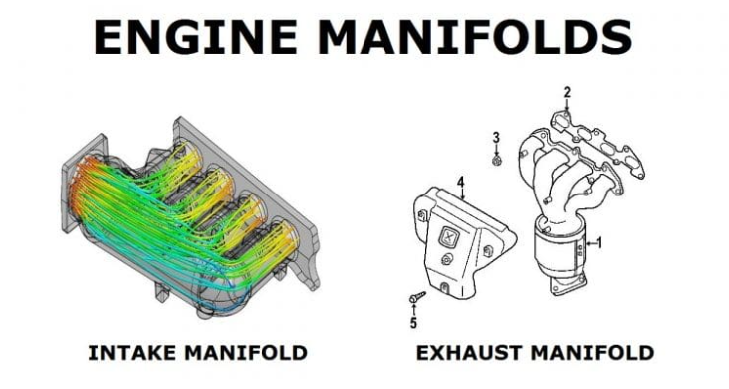

Phase—An impulse of alternating current. The number of phases depends on the generator windings. Most large generators produce a three-phase current that must be carried on at least three wires.

Polarity: The direction of magnetism or direction of flow of current.

Revision Block: This block is located in the upper right corner of a print. It provides a space to record any changes made to the original print.

Stretch-out Line: The base or reference line used in making a development.

Temper: To harden steel by heating and sudden cooling by immersion in oil, water, or other coolant.

Title Block: A blocked area in the lower right corner of the print. Provides information to identify the drawing, its subject matter, origins, scale, and other data.

Floor Area Ratio (FAR): A rule that tells you how big a building can be compared to the size of the land it's on. It’s like a ratio that shows how much building space you can have on a piece of land. For example, if the FAR is 2 and the land is 1,000 square feet, you can build up to 2,000 square feet of floor space on that land. It helps control how much building can fit on a piece of land to keep areas from getting too crowded.

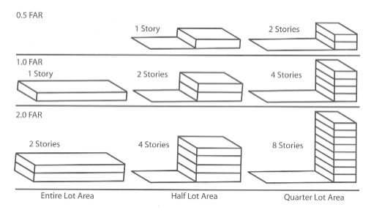

Zone Numbers: Numbers and letters on the border of a drawing to provide reference points to aid in indicating or locating specific points on the drawing. Zoning codes often include both height limitations and FAR limitations. Where land is concerned: A zoning code is just ashort combination of letters and numbersthat determines what you can build on a particular plot oflands. A zoning code of C-1, for instance, might indicate low-rise commercial development.

